**Monument: (1-3) Unidentified Late Hellenistic Buildings**

Date: Late Hellenistic period, 2nd century B.C. or later

Material: Vuggy crystalline limestone, marble thresholds

Location: Western Hill

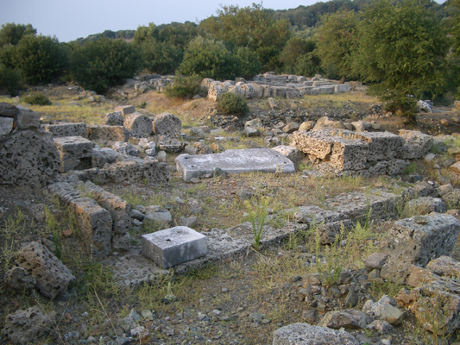 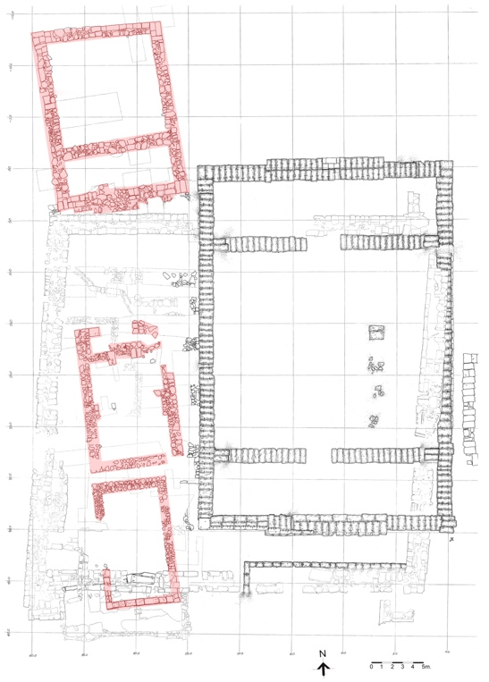

Caption: (Left) Foundations of Buildings 1, 2, and 3 (Right) Plan of area. © American Excavations Samothrace

Three relatively small, rectangular buildings made of local limestone are aligned along the western perimeter of the Sanctuary, north of the Stoa on the Western Hill and west of the large unfinished Hellenistic structure (Building A) of an earlier date. The northern two buildings (1 and 2) faced each other, while the southern-most building (3) was oriented toward the south. Building 1, the largest, had a hexastyle prostyle porch, most likely of the Doric order. Building 2 had a porch composed of two columns in antis and in Building 3, pillars rather than columns formed the two supports of the façade. In scale and design these three buildings resemble treasuries found at other Greek sanctuaries such as Delphi, Olympia, Nemea, and Delos. Their function at Samothrace, however, remains uncertain.

During excavation in the area in 1927, the French-Czech team revealed the foundations of the porch of Building 1. Buildings 2 and 3, as well as the rest of Building 1 were uncovered in J. R. McCredie’s investigations north of the Stoa plateau during the 1965-1968 and 1970 seasons.

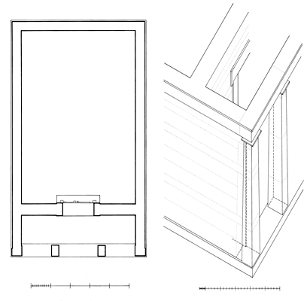

Caption: Reconstruction of Building 2. © American Excavations Samothrace

Selected Bibliography:

Lehmann, K. 1998. *Samothrace: A Guide to the Excavations and the Museum*, 6th ed., rev. J.R. McCredie, Thessaloniki, p. 113.

McCredie, J. R. 1979. “Samothrace; Supplementary Investigations, 1968-1977,” *Hesperia* 48, pp. 24-26.

Wescoat, B. D. 2010. “Up against the Wall: Antae in Samothracian Architecture,” in *Samothracian Connections; Essays in Honor of James R. McCredie,* eds. O. Palagia and B. D. Wescoat, Oxford, pp. 75-106.

Document updated: Glennon 20211120